S11_2420030197_ExperimentNo 3_ ExperimentName :- Jira Software

- Open a web browser.
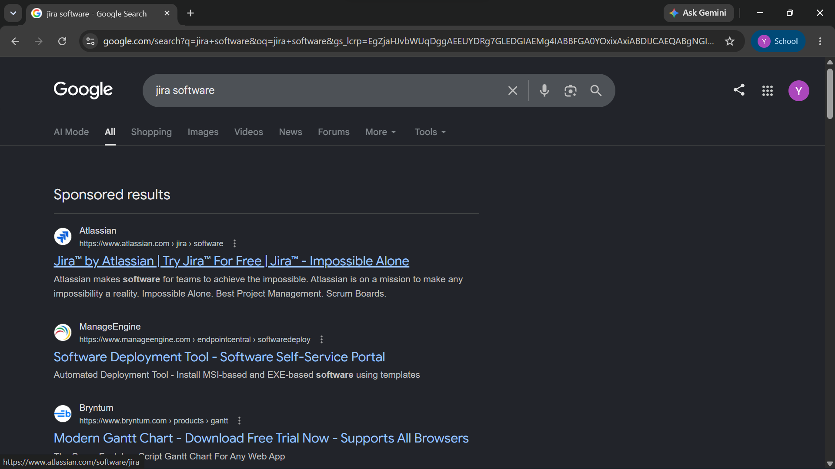
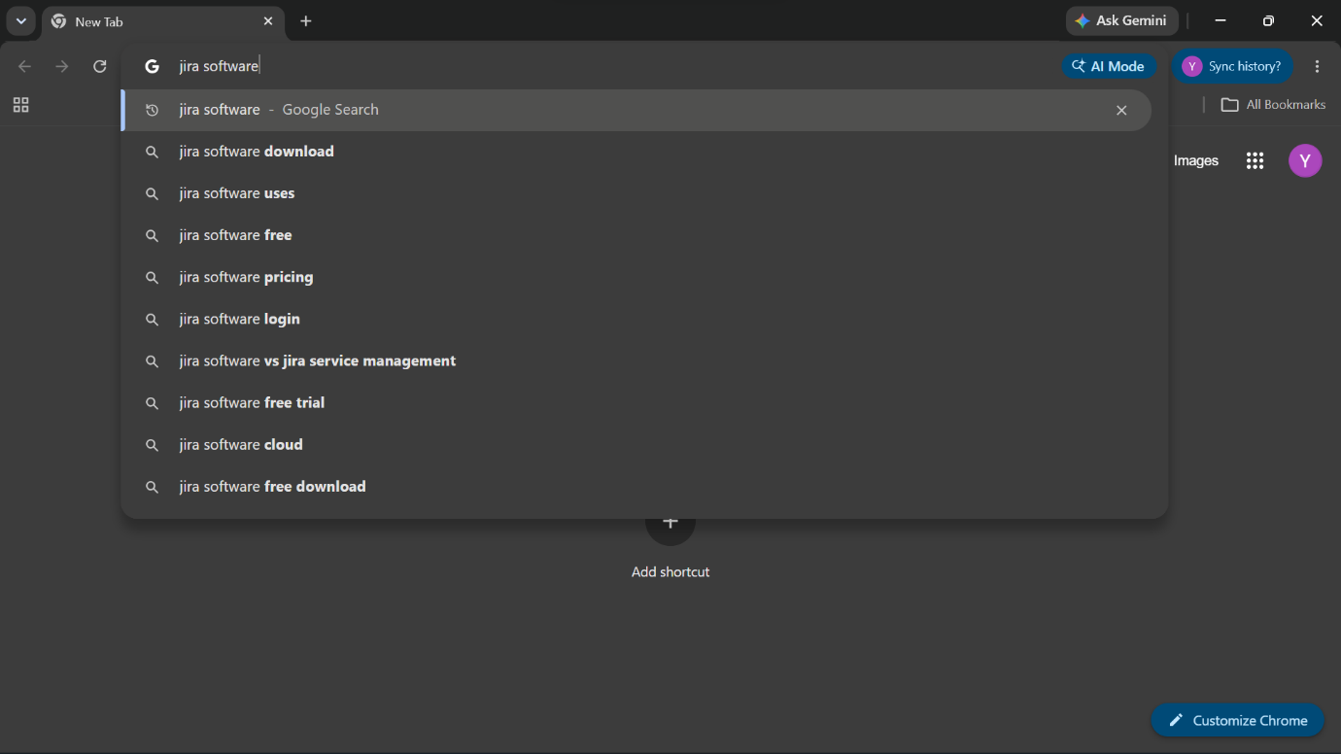
- SearchJira Software.

- Click on Jira Atlassian.
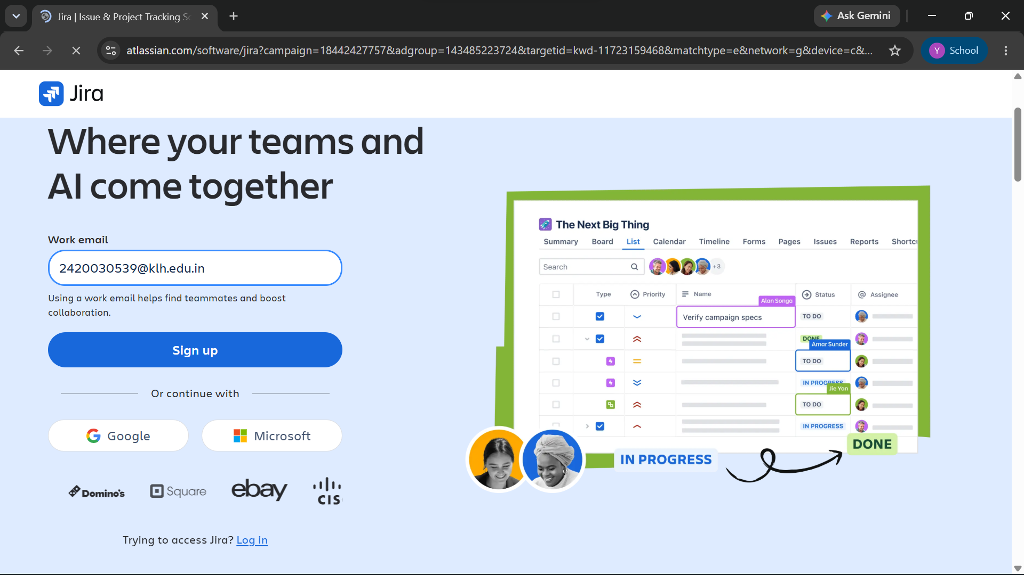
- Sign up or log in using your Atlassian account.
- Create a Software Project.
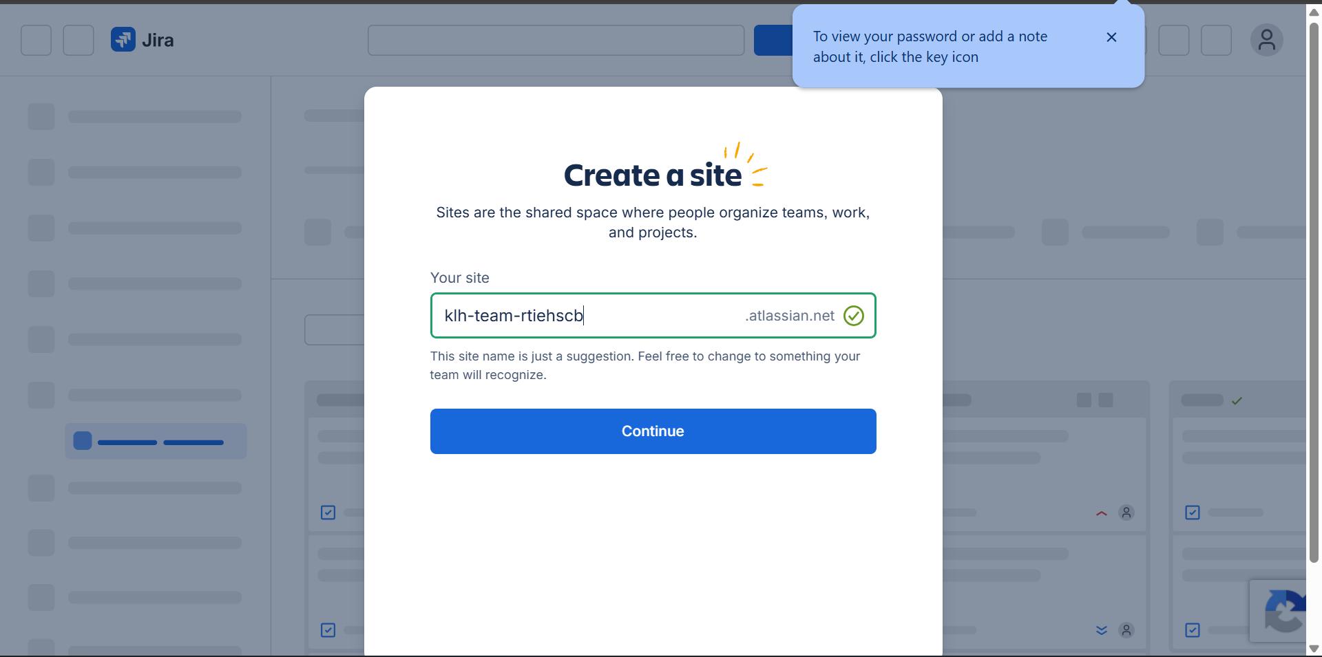
- Select the Scrum project template.
- Enter the project name and create the project.
- Create Epics for major modules.
- Create User Stories under each Epic.
- Add all user stories to the Product Backlog.
- Create a Sprint.
- Move backlog items to the sprint.
- Assign tasks to team members.
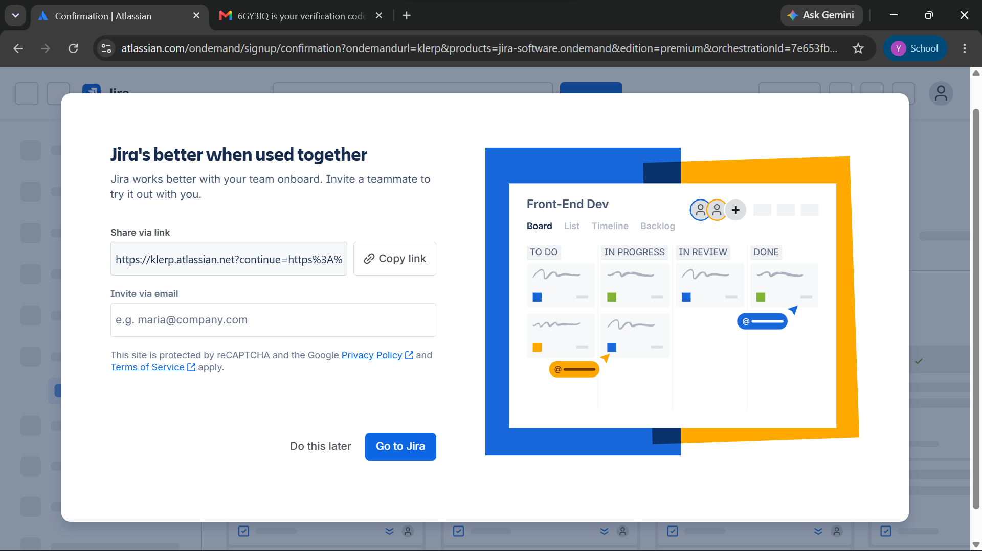

- Set the priority for each task.
- Start the sprint.

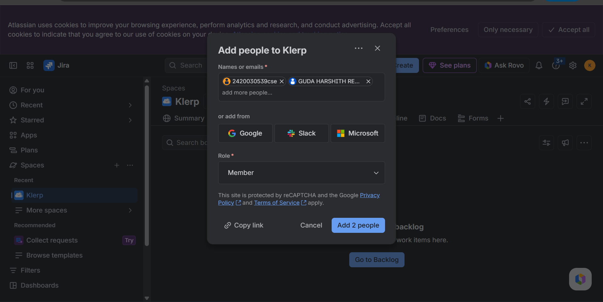

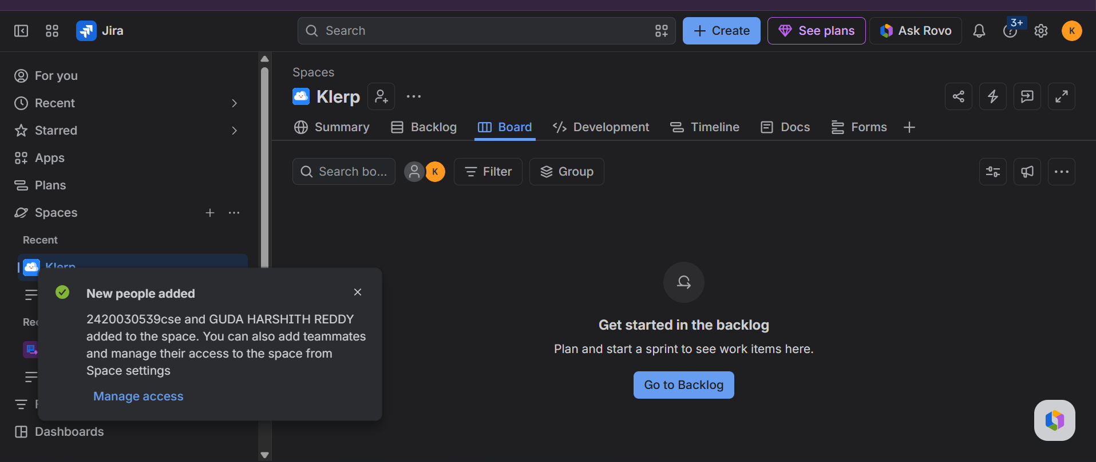

- Update task status (To Do → In Progress → Done).
- Track progress using the Scrum Board.
- View sprint reports and burndown chart.
- Complete the sprint after finishing all tasks.

Outcome
Successfully learned how to use Jira Software for project planning, sprint management, task assignment, and progress tracking.

